GLOBAL
ROTAX MAX Challenge
Technical Regulation 2026

Bulletin no. : 04
Valid from : 2026 June 05
Addendum/changes (highlighted in yellow) to Global RMC Technical Regulation 2026, Edition 2026 October 09 Version 1

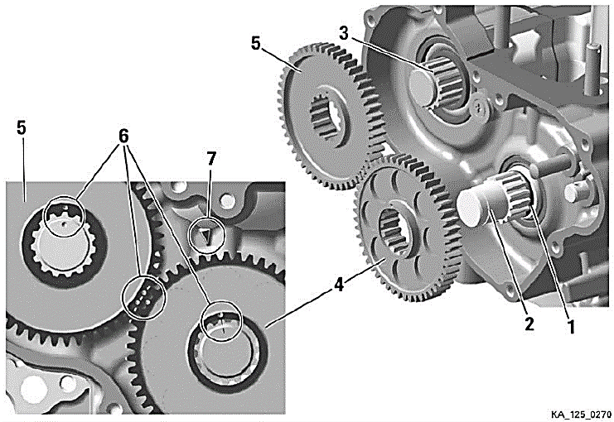
BALANCE DRIVE and gear oil
125 Micro MAX, 125 Mini MAX,125 Junior MAX and 125 Senior MAX:
Steel balance gears only (minimum width = 8,8 mm) are legal to be used.
Balance gears must be installed and must be aligned according to the instruction in the repair manual.
A minimum volume of 50ml of gear oil must be able to be sampled at all times during the event.
XPS KART GEAR Oil must be used, changing of the gear oil for an alternative brand is not permitted.
The measured oil must be extracted by the competitor or representative via the port for this purpose in a maximum of 1 minute. It is the competitor’s responsibility to capture all extracted oil in the provided container; any waste or spillage will not be counted as part of the measurement.
It is permitted to remove the engine from the kart and to tilt it during this process to help drain all the oil through the dedicated port.

125 MAX DD2:
Balance drive gear must be fitted on crank shaft.
Balance gear must be fitted on primary shaft and must be aligned with the balance drive gear according to the instruction in the repair manual.
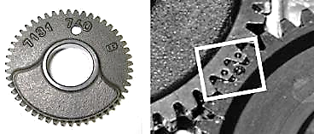
Version 1:
Fly weight of balance gear must show cast surface

Version 2:
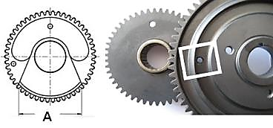
Fly weight of balance gear can show machined surface.
Dimension A (widest part of balance weight) must be either:
 | Length | Tolerance
Dimension A | 53,0 mm | +0,50 mm
Dimension A | 53,0 mm | -0,50 mm
Dimension A | 57,0 mm | +0,50 mm
Dimension A | 57,0 mm | -0,50 mm

The minimum weight of a dry balance gear including bearing must not be lower than 240 grams.
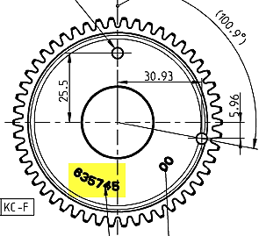
Version 3:
ROTAX part number 635745 (visible on the gear).
Fly weight of balance gear can show machined surface.
The minimum weight of a dry balance gear including bearing must not be lower than 255,0 grams.

A minimum volume of 100ml of gear oil must be able to be sampled at all times during the event.
XPS DD2 KART GEAR Oil must be used, changing of the gear oil for an alternative brand is not permitted.
The measured oil must be extracted by the competitor or representative via the port for this purpose in a maximum of 1 minute. It is the competitor’s responsibility to capture all extracted oil in the provided container; any waste or spillage will not be counted as part of the measurement.
It is permitted to remove the engine from the kart and to tilt it during this process to help drain all the oil through the dedicated port.

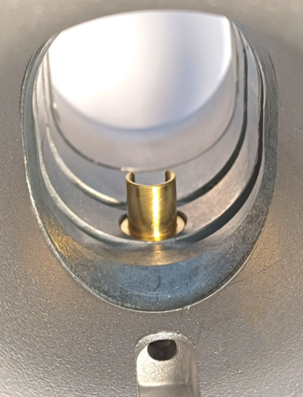
CARBURETTOR
Dellorto carburettor, housing must show the cast wording “VHSB 34”
Carburettor housing is stamped with “XS”.
The lower entrance of the inlet bore of the carburettor must show a cast surface (See picture for reference, strictly no machining allowed in the area indicated by the red arrow).
Control machining maybe evident in and through the center of the venturi bore and on the edges of the venturi where it meets the cast body.
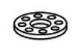
Optional item ROTAX main jet cup, is legal to be used.
This part optionally replaces the part 261550.
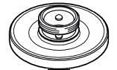

Optional carburettor plug screw marked "ROTAX" (ROTAX part no. 261 030) is legal to be used.

The two vent fittings must be connected with the original air vent hose min 155 mm (Rotax 260260). The location of the opening has to be placed at the rear side of the carburettor
Settings of the carburettor adjustment screws (idle and idle air) are free.
The Position of the jet needle is free.
All jets must be correctly seated and securely fitted at any time (tightened)!
A minimum required size of main jet may be determined for each race event by a “Bulletin”.
The venturi holes of the carburettor insert can show signs of a CNC control machining.
Carburettors insert maybe used with 1 or 2 gaskets placed between the insert and the body of the carburettor.
FUEL SIEVE
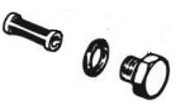
Carburettor can be used with and without fuel sieve in the carburettor housing.

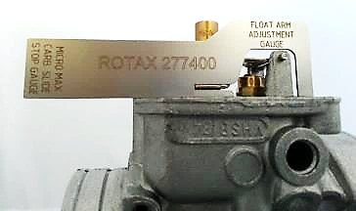
The height of the two arms of the float lever must be within the slot of the carburettor gauge (Rotax 277400) by their normal weight measured at carburettor housing without gasket in reverse upright Position.

Needle valve assembly stamped "150"
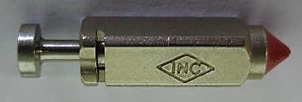
A pin gauge measuring 1.56mm may not pass through the central bore, No pressure may be applied.
Needle valve must be marked with diamond symbol” INC" only.
Start jet is stamped with the digits “60”.

Any Dellorto main jet number even if not offered from Rotax is legal to be used.
Carburettor slide shows digits “45” in casting.
Jet needle must be stamped with “K57”.
Two floats marked "4,0 gr" are legal to be used only

Needle jet stamped with” DP267”

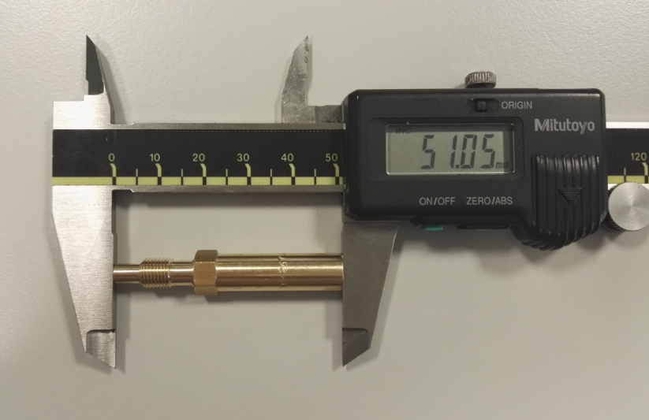
 | Length | Tolerance
Total Length | 51,0 mm | +0,50 mm
Total Length | 51,0 mm | -0,50 mm
 | Length | Tolerance
Bottom section | 33,0 mm | +0,45 mm
Bottom section | 33,0 mm | -0,45 mm

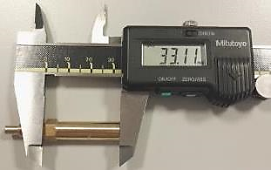

 | Diameter | Tolerance
Top Bore | 2,67 mm | +0,10 mm
Top Bore | 2,67 mm | -0,10 mm
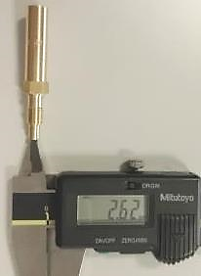

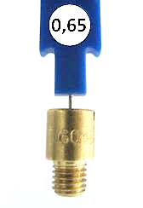
Idle jet
Idle jet has to be stamped with 60.
Plug gauge 0,65 mm may not pass through the central bore, No pressure may be applied.
For this test, the pin gauge shall be sufficiently extended from the holder to ensure that the plastic holder does not interfere with the measurement.
(Use jet gauge set Rotax part no. 281 920).

Idle emulsion tube
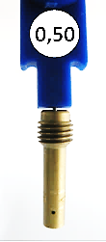
Idle emulsion tube has to be stamped with 45.
Plug gauge 0,50 mm may not pass through the central bore, No pressure may be applied.
For this test, the pin gauge shall be sufficiently extended from the holder to ensure that the plastic holder does not interfere with the measurement.
.
(Use jet gauge set Rotax part no. 281 920)

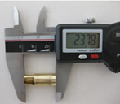
Atomizer
Remove atomizer from carburettor body by means of venturi tool set (Rotax part no. 676 034)
 | Total Length | Tolerance
Atomizer | 23,75 mm | +0,35 mm
Atomizer | 23,75 mm | -0,35 mm

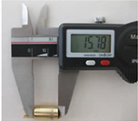

 | Cylindrical Length | Tolerance
Atomizer | 15,75 mm | +0,25 mm
Atomizer | 15,75 mm | -0,25 mm

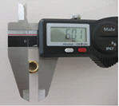
 | Cutaway Dimension | Tolerance
Atomizer | 5,8 mm | +0,30 mm
Atomizer | 5,8 mm | -0,30 mm

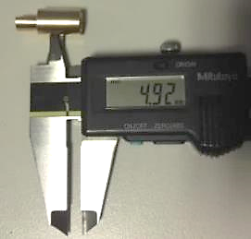

 | Cross bore Dimension | Tolerance
Atomizer | 5,0 mm | +0,15 mm
Atomizer | 5,0 mm | -0,15 mm

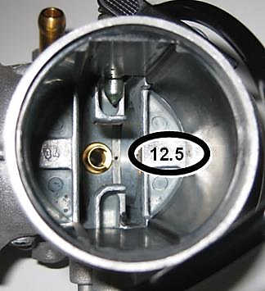
Carburettor insert must show stamping: “12,5”

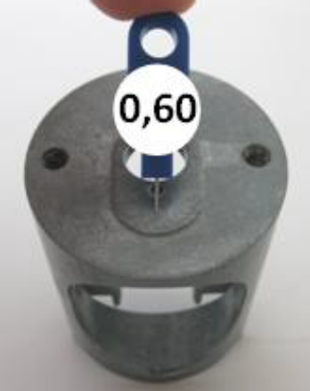
Angular bore of carburettor inserts
Plug gauge 0,60 mm may not pass through the central bore, No pressure may be applied.
For this test, the pin gauge shall be sufficiently extended from the holder to ensure that the plastic holder does not interfere with the measurement.
(Use jet gauge set Rotax part no. 281 920).

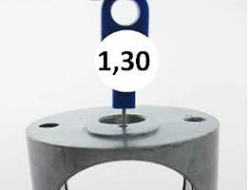
Vertical bore of carburettor inserts
Plug gauge 1,30 mm may not pass through the central bore, No pressure may be applied.
For this test, the pin gauge shall be sufficiently extended from the holder to ensure that the plastic holder does not interfere with the measurement.

(Use jet gauge set Rotax part no. 281 920).
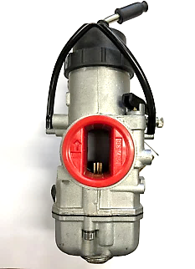
125 Micro MAX and Mini MAX:
The throttle body restrictor must be fully inserted into the carburettor body and in the correct orientation at all times.
(See picture for reference).
ROTAX part number: 267536
No modifications are allowed, the ribbed surface on the inlet is to help ensure dimensions have not been modified.

Max distance = 35,0 mm  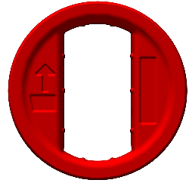 |  | 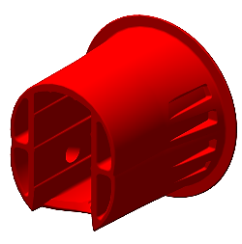
Max distance = 18,0 mm  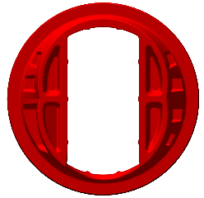 | Min length = 35,0 mm   | 